**Semiconductor Etching Tool Health Assessment**

**Background**

The focus of this project is to develop a health assessment system for a set of LAM 9600 TCP metal etchers at a semiconductor manufacturing facility (FAB). The end goal is to provide a reduction in downtime of machines giving a higher yield output. Baseline data for 21 controller parameters from 3 metal etchers were collected to help identify problems faced. Our health assessment system provides a health indicator and threshold for determining whether the system is normal or degraded. All data was imported, structured, and trained in Python (Google Collab).

**Flow Chart**

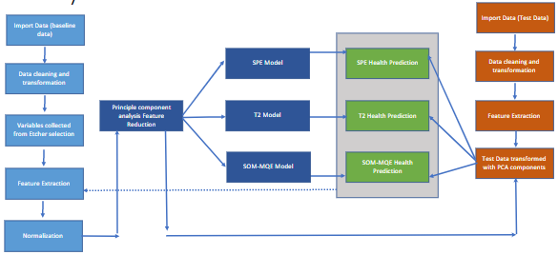

**Data Visualization**

The following data variables provided were to be used in determining which features should be used in our model.

|  |  |
| --- | --- |
| **Variable #** | **Variable Name** |
| 1 | Time |
| 2 | Step_Number |
| 3 | BCl3_Flow |
| 4 | Cl2_Flow |
| 5 | RF_Btm_Pwr |
| 6 | RF_Btm_Rfl_Pwr |
| 7 | Endpt_A |
| 8 | He_Press |
| 9 | Pressure |
| 10 | RF_Tuner |
| 11 | RF_Load |
| 12 | RF_Phase_Err |
| 13 | RF_Pwr |
| 14 | RF_Impedance |
| 15 | TCP_Tuner |
| 16 | TCP_Phase_Err |
| 17 | TCP_Impedance |
| 18 | TCP_Top_Pwr |
| 19 | TCP_Rfl_Pwr |
| 20 | TCP_Load |
| 21 | Vat_Valve |

The following array of graphs shows an example from Etcher 1 plots for each data variable.

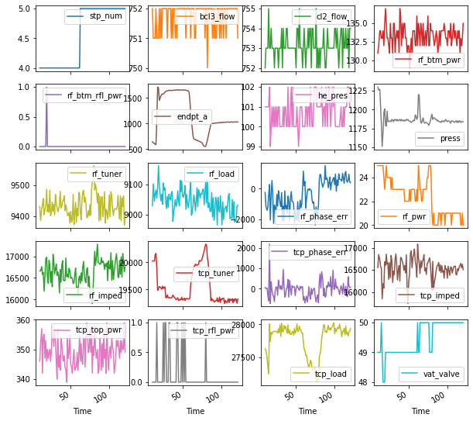

**Feature Extraction & Normalization**

From our data visualization, we plotted each time domain feature to get a sense of variability from every set. Those parameters that showed the most variation (most data to extract) were chosen. A sample graph of how we chose our parameters are shown below. It also shows differences in test and training data. Using the machine variable titled “stp_num”, data from processes 5 and 6 could be isolated as individual data sets.

The controller parameters we felt had the most variability is RF_pwr, BCL3_flow, and tcp_load. Through iterative testing, we believe these also yield the best results. From here, we develop a feature matrix using the time domain features of mean, standard deviation, skewness, variance, root mean square, and peak-to-peak. Combining this from the data in processes 5 and 6, we obtain 36 useful features. Using the min-max scaler, we can create a normalized feature matrix, for each etcher, to train our model.

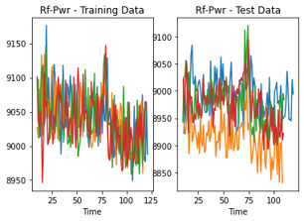

**Feature Reduction**

Principal Component Analysis (PCA) is a dimension reduction technique that maintains most of the information in multi-dimensional data. It was used for feature reduction in developing our T2 model. 12 principal components, from 36, were used in developing our PCA visualization. It’s five steps are shown below. [1]

1. Normalization so that each variable has zero mean and unit variance
2. Obtain the covariance matrix
3. Calculate the eigenvectors and eigenvalues of the covariance matrix
4. Determine the number of principal components (PC) to keep
5. Project the original data into PC space.

This 3D plot shows 3 principal components where the best feature is ptp_bcl3_flow_prc2 that explains 44.3% of the variation.

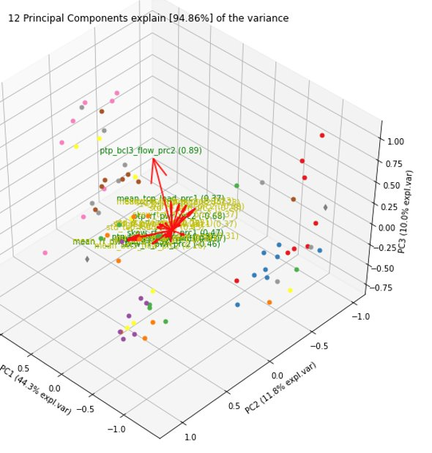

The following plot shows the 12 principal components, from 36, that cumulatively explain 94.86% of the variance.

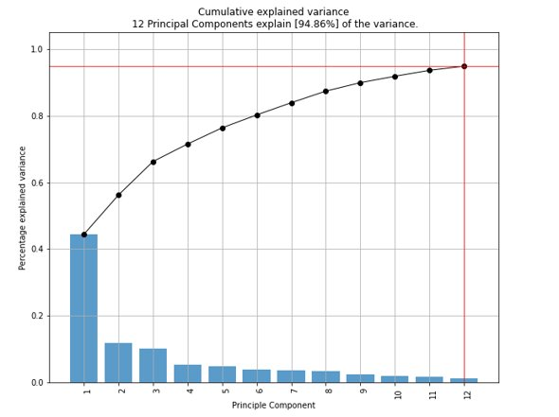

**Health Assessment**

Hotelling’s T2 is a multivariate probability distribution that is a counterpart to a univariate T-distribution. Hotelling’s T2 and squared prediction error (SPE) are used as the health indicator to tell whether the data set is deviating from the normal condition. The health limit for T2 and SPE are calculated based on a designated confidence limit. An example healthy training data T2 scores are shown below.

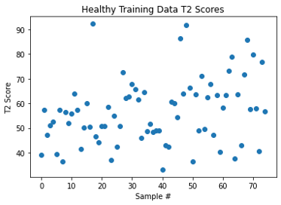

The T2 threshold was decided by observing the mean and standard deviation of the T2 health metric. The following graphs show T2 plots for each etcher and a conclusive table highlighting model predictive accuracy.

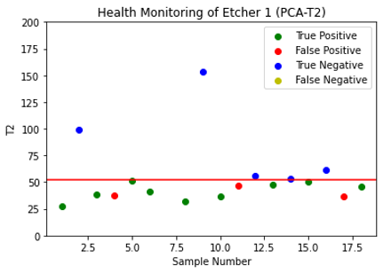

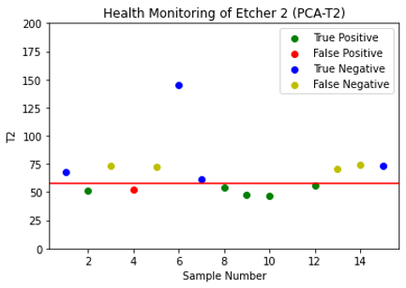

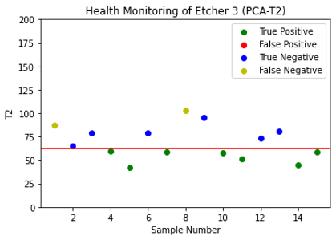

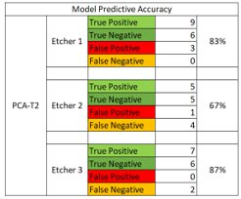

Square prediction error (SPE) is the expected value of the squared difference between the fitted values and the model. The following graphs show SPE plots for each etcher and a conclusive table highlighting model predictive accuracy.

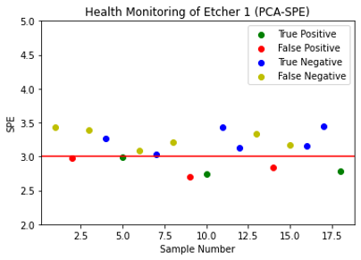

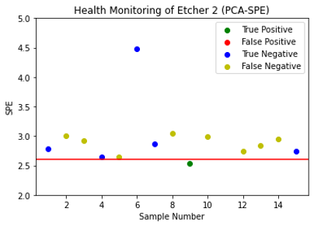

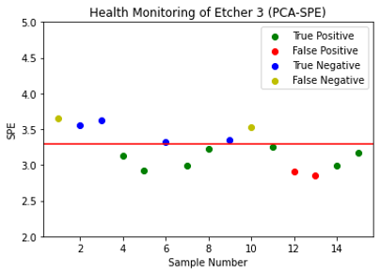

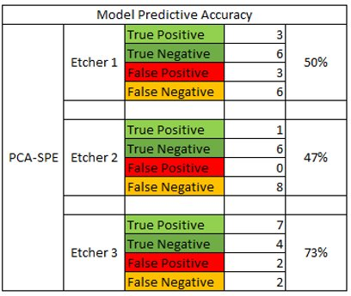

A self-organizing map (SOM) is a useful tool for mapping multi-dimensional neural networks to a lower-dimension space. An unsupervised map, shown below, was generated using only the training (healthy) data. The MiniSOM function library was used to generate the SOM.

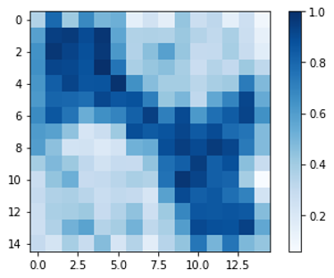

Minimum quantization error (MQE), regarding SOM, is calculated based on the Euclidean distance between the best matching unit of a trained map and the input feature vectors. By using MiniSOM’s quantization error method for all test samples, an MQE health could be calculated and is shown below.

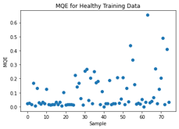

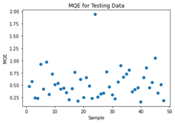

A threshold was decided by observing the maximum MQE of the healthy data for each individual etcher (shown by red line below). The following graphs show MQE plots for each etcher and a conclusive table highlighting model predictive accuracy.

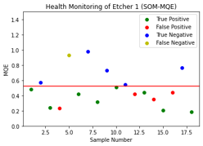

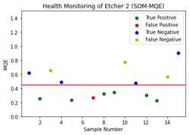

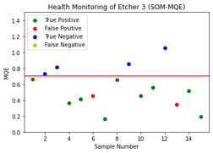

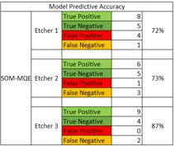

**Conclusion**

At the end, we were able to train our PCA and SOM models to be used for health monitoring of the semiconductor etching system. PCA-T2 and SOM-MQE predicted results very well (87% for Etcher 3), whereas PCA-SPE was slightly worse. We would recommend using T2 model overall but use SOM-MQE for Etcher 2. Further threshold analysis could be done to limit the number of false positives if required. These models show that implementation of health metrics may save a significant amount of time on etching inspection.

**Works Cited**

[1] Jin, C. (2015). *A Sequential Process Monitoring Approach using Hidden Markov Model*  *for Unobservable Process Drift.* [Master’s thesis, University of Cincinnati].